CREATE TABLE MOBIL (

IMEI INT(11) PRIMARY KEY NOT NULL,

fabricant VARCHAR(20),

model VARCHAR(20),

ram enum('2','4','8','16','32'),

espai enum('32','64','128','320')

);

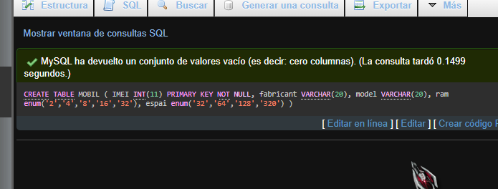

CREATE TABLE IOS (

imei INT(11) PRIMARY KEY,

version INT,

lliberat BOOLEAN,

FOREIGN KEY (imei) REFERENCES MOBIL (imei)

);

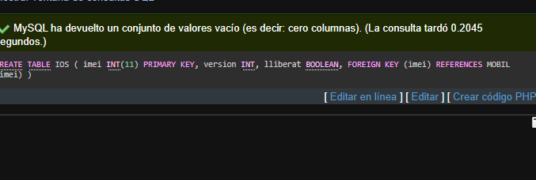

CREATE TABLE ANDROID(

imei INT(11) PRIMARY KEY,

nomVersio VARCHAR(20),

FOREIGN KEY (imei) REFERENCES MOBIL (imei)

);

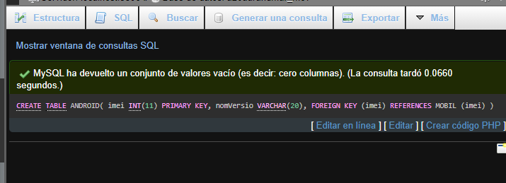

CREATE TABLE USUARI (

codi INT(11) AUTO_INCREMENT PRIMARY KEY,

nom varchar(20),

cognom varchar(20)

);

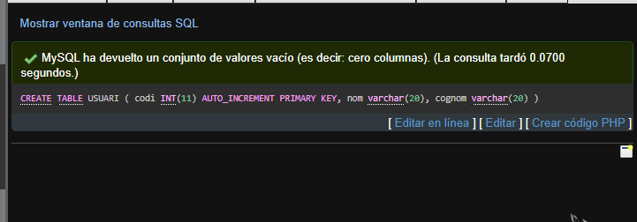

CREATE TABLE APLICACIO (

nom VARCHAR(20) PRIMARY KEY,

desenvolupador VARCHAR(20),

calificacio enum('1','2','3','4','5')

);

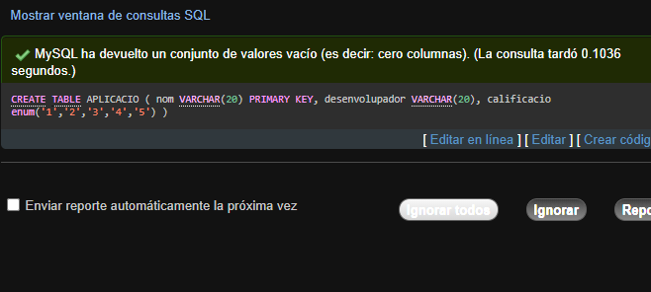

CREATE TABLE HISTORIC_US (

usuario INT(11),

movil INT(11),

data_ini DATE,

data_fi DATE,

PRIMARY KEY (usuario, data_ini),

FOREIGN KEY (usuario) REFERENCES USUARI(codi) ON UPDATE CASCADE ON DELETE CASCADE,

FOREIGN KEY (movil) REFERENCES MOBIL(imei) ON UPDATE CASCADE ON DELETE CASCADE

);

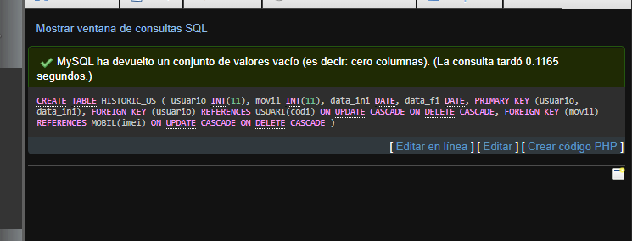

CREATE TABLE INSTALACIO (

mobil INT(11),

aplicacio VARCHAR(20),

versio INT(11),

PRIMARY KEY(mobil, aplicacio),

FOREIGN KEY (mobil) REFERENCES MOBIL(imei),

FOREIGN KEY (aplicacio) REFERENCES APLICACIO(nom)

);

